 | FINAL TERM EXAMINATION  SEMESTER FALL 2005  CS408-HUMAN COMPUTER INTERACTION | Total Marks: 130
WWW.VUTUBE.EDU.PK

StudentID/LoginID

Name

PVC Name/Code

Date

Please read the following instructions carefully before attempting any of the questions:
- This examination is take home.

**WARNING: Please note that Virtual University takes serious action against unfair means. Anyone found involved in cheating will get an `F` grade in this course.

For Teacher’s use only
Question | Q1 | Q2 | Q3 | Q4 | Q5 | Total
Marks

Question No: 1 | Marks: 20

The screenshot given below shows the home page of a web site. Firstly, explain the meaning of the heuristics given below. Secondly, use these heuristics to evaluate the Web page to determine whether it is successful in conveying the ‘big picture’ to the user.



Home Page Heuristics
- What is this?
- What do they have here?
- What can I do here?
- Why should I be here and not somewhere else?

Question No: 2 | Marks: 30

Perform the trunk test on the screenshot given below. Provide an explanation of your answers.
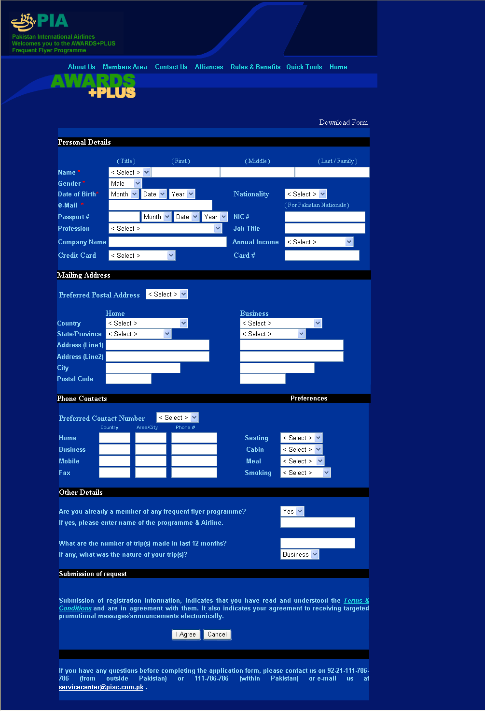

Trunk Test Heuristics
What site is this? (Site ID)
What page am I on? (Page Name)
What are the major sections of this site? (Sections)
What are my options at this level? (Local navigation)
Where am I on the scheme of things? (“You are here” indicators)
How can I search? (Search)

Question No: 3 | Marks: 30

Find web pages that illustrate the principle of consistency. You must provide one good example and one bad example of consistency. You must provide screenshots of the relevant web pages along with the URL and a written explanation justifying the good and bad example in your answer. To find relevant examples, browse the Internet. Also provide a written description defining the principle of consistency.

Question No: 4 | Marks: 30

Find web pages that illustrate the principle of constraints. You must provide one good example and one bad example of constraints. You must provide screenshots of the relevant web pages along with the URL and a written explanation justifying the good and bad example in your answer. To find relevant examples, browse the Internet. Also provide a written description defining the principle of constraints.

Question No:5 | Marks: 20

Give one example of what critical problems can be caused when computer technology is integrated into devices and machines of everyday use. Your answer must give an account of a real (not fictional) event which illustrates the importance of usability in computer-based systems.

